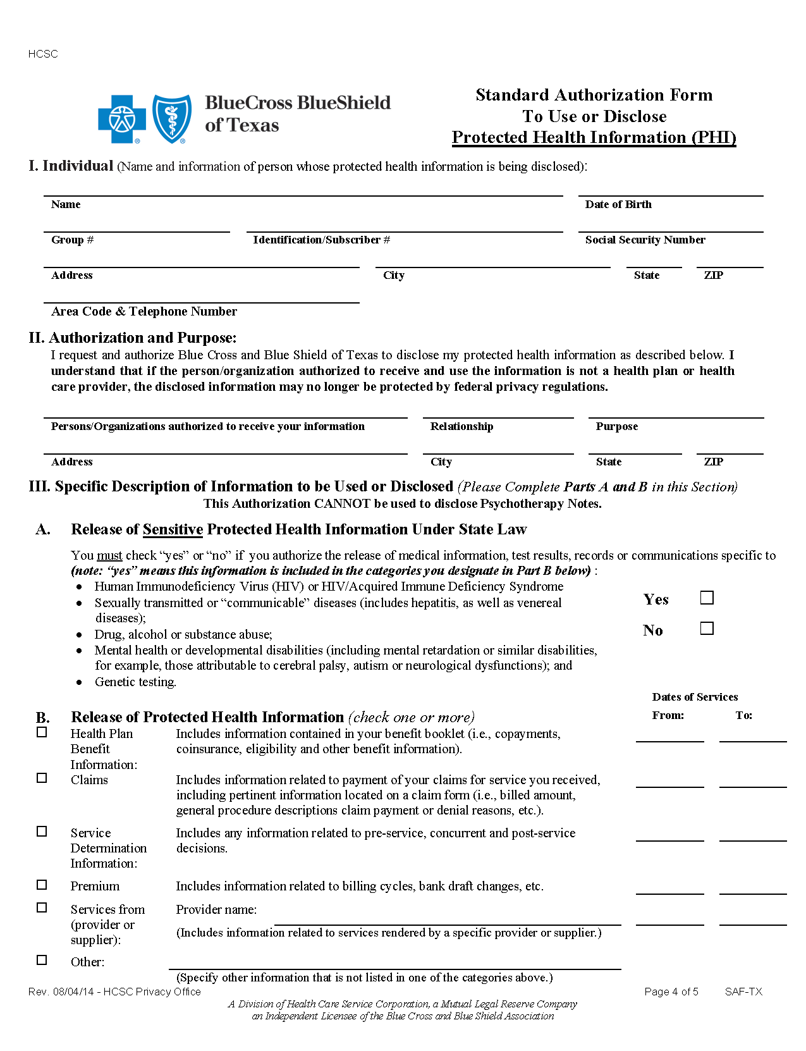
Batman
01/01/1979
xxx-xx-5555
Axiom Requisition Copy Service
Litigation
2869 Jolly Road
Okemos
MI
48864
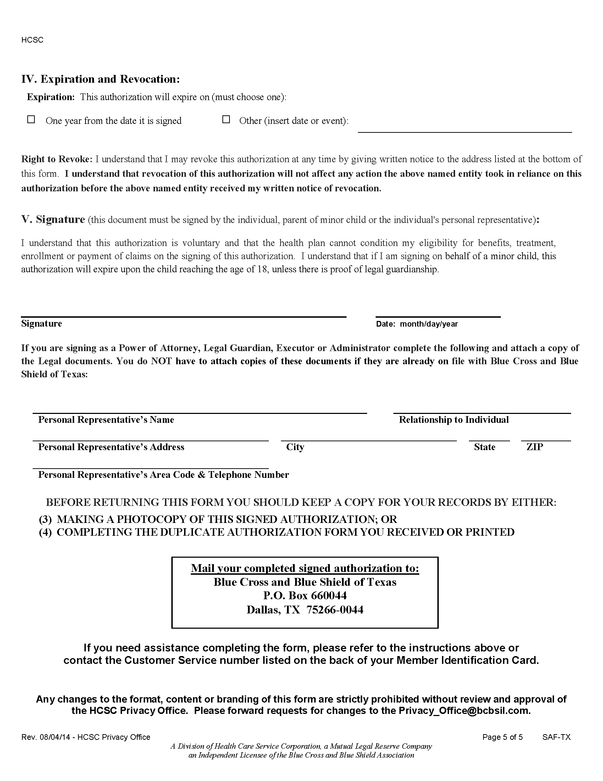
✓

End of Litigation

